

25/10/2022 | Budget Sales
 | Analysis
 | Wireframe Documentation

INEURON.AI

Presented by: Adil Anwar

Github:- GITHUB LINK OF CODE

Linkedin Profile:- https://www.linkedin.com/in/adil-anwar-1b480b106
Homepage

As per the problem statements

1. Revenue distribution by Country and Regions.
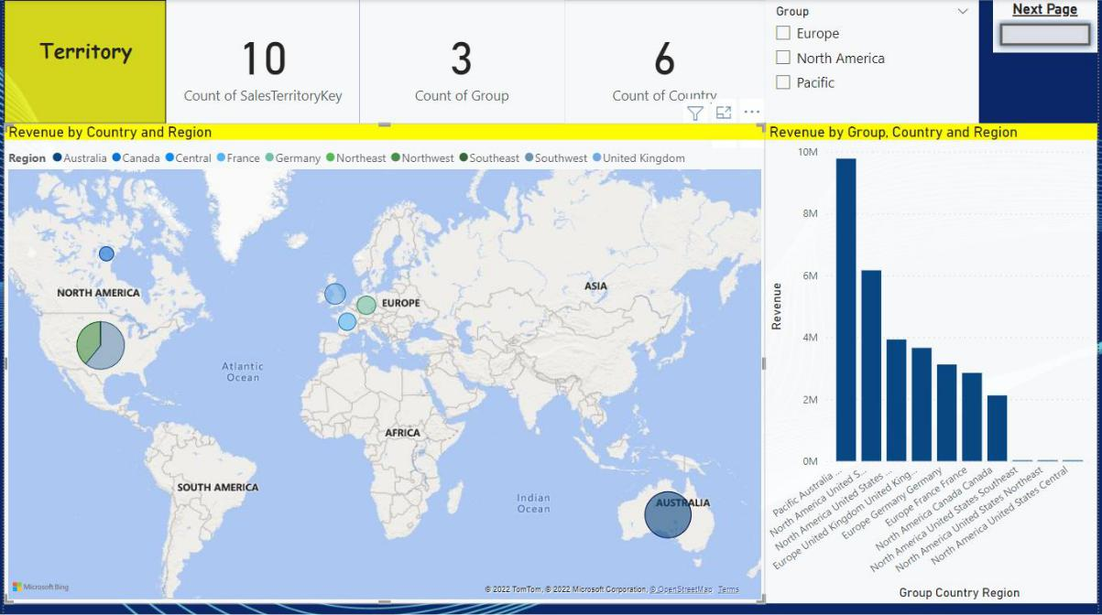

- Product and its category and relation between revenue, list price, standard cost with categories and subcategories.
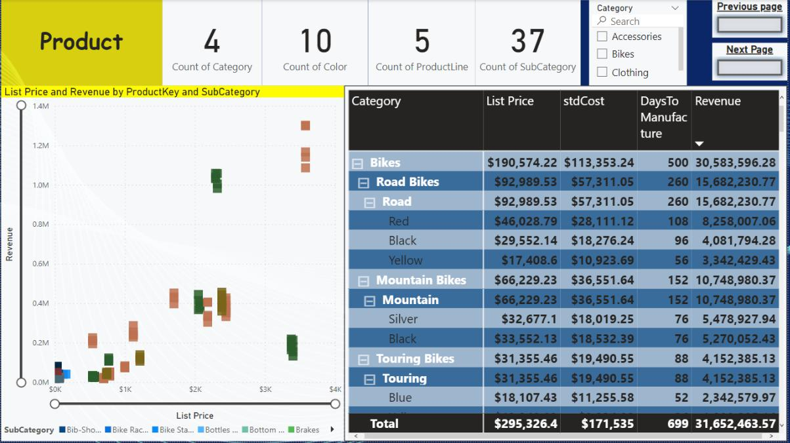
- Total number of customers, their income distribution(gender-wise), and revenue by occupation and education
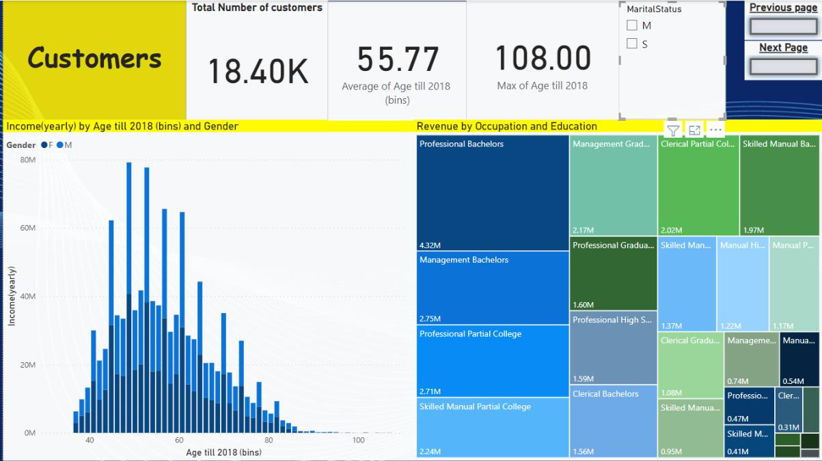

- Distribution of profit over a month, quarter, year, and fiscal year. Weekday and weekend distribution.
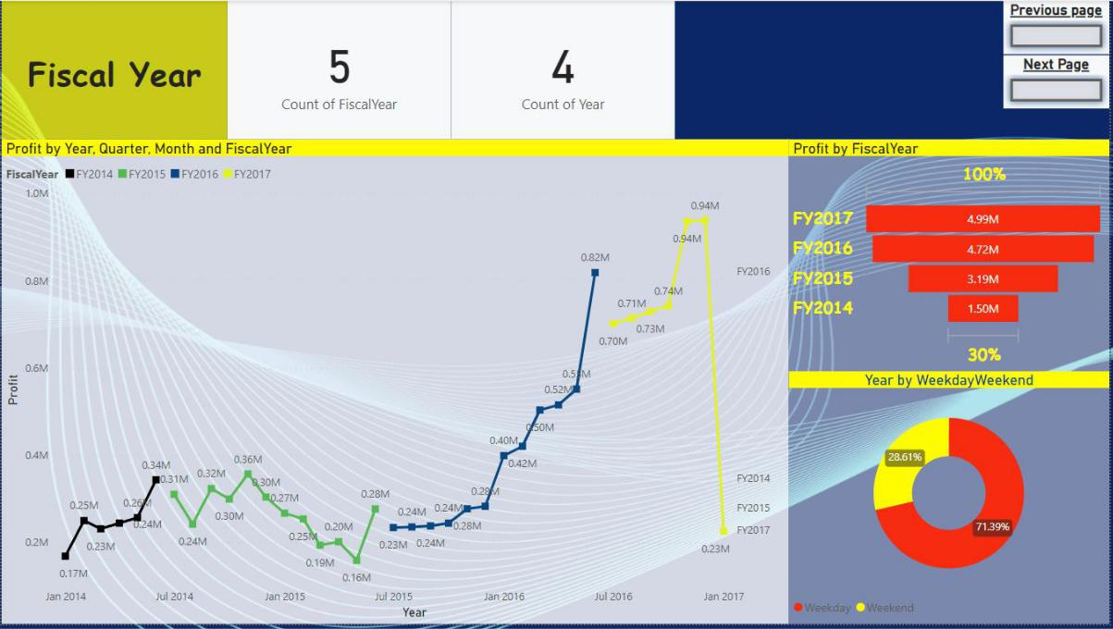

5.

- tax amount by category, KPI of profit and Tax amount by category, Unit price by sub category, Expenses and profit by group
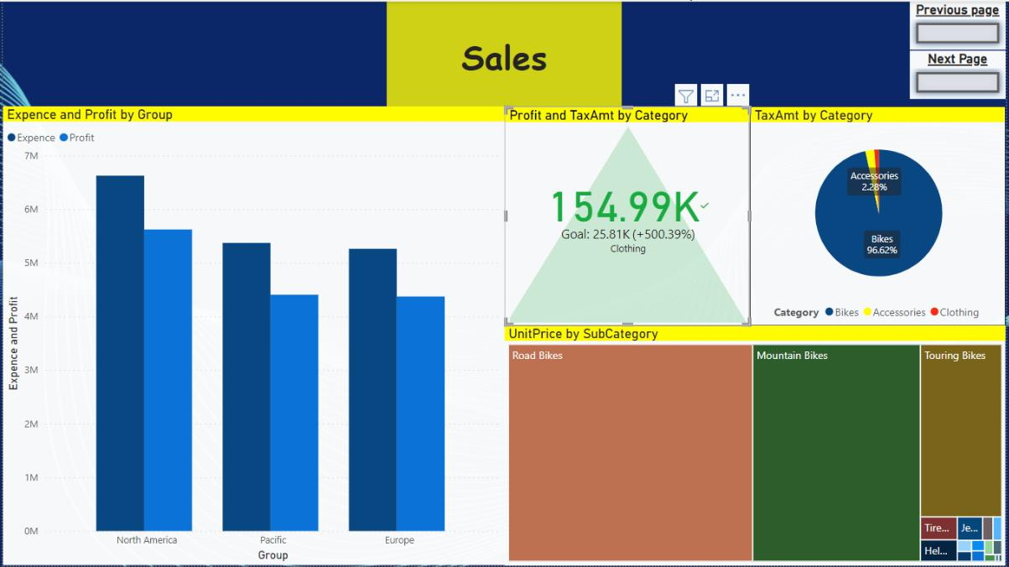

6. Budget Data in the year of 2016
